4 LOCAL CHAPTERS
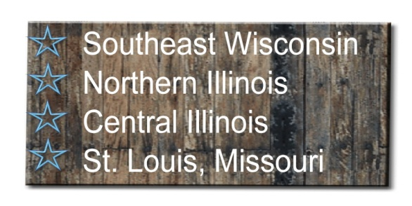
- Regular evening meetings in each chapter’s area

- Stay abreast of new product offerings and changes in our industry through industry member presentations

- Talk shop with your favorite refreshment

- Information regarding new laws and regulations

- Entertaining and pertinent information presented by various speakers
- Social Outings

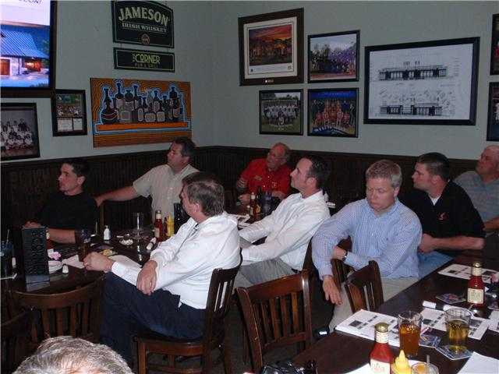

Ideas to help you be more
efficient and profitable…
That’s what it’s all about!!!

“To provide an avenue for its members to exchange ideas, obtain educational offerings and to monitor legislative and regulatory actions”
Contact us:
CSDDA
PO Box 4386
Naperville, IL 60567-4386
Email: admin@csdda.com
www.csdda.com

CENTRAL STATES
Proud to be an affiliate member of the International Door Association

CENTRAL STATES DOOR DEALERS ASSOCIATION
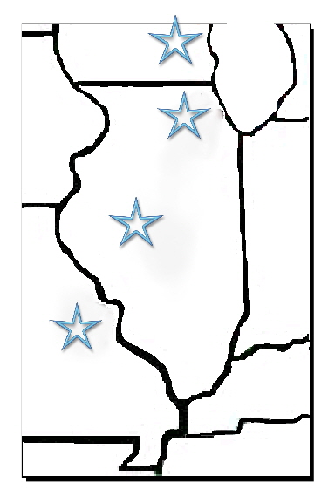
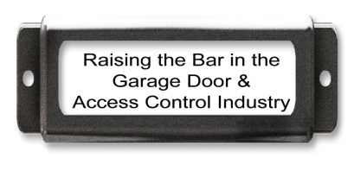
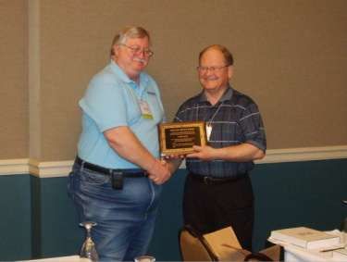
Regional Conference

- Management speakers and seminars for owners and managers

- Technical Workshops for installers at little or no charge

- Institute of Door Dealer Education and Accreditation (IDEA) testing

- A chance to view or display industry members’ information and products

- Relevant, interesting speakers and seminars for every member of your team

- More local opportunity than IDA’s expo to bring installers and team members for training and education
Why I joined CSDDA:
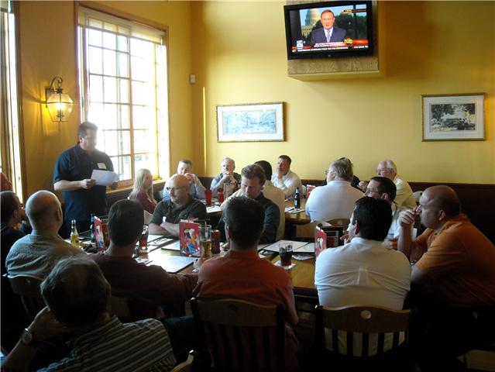
“It gives us an opportunity to exchange ideas and provides a venue to obtain educational offerings in a group setting.”

“For the ability to network with other members of our industry. I also appreciate the inside tracking of new regional safety and legal issues.”
To learn things I may never have learned, or had to learn the hard way, from other professionals in the industry.
Meeting sponsorship coupled with our donation of door prizes and the publicity generated from such has proven to be an invaluable marketing tool.

What will I find on www.csdda.com?
- Member company names, contact information, products offered, logo, link to their website

- Updated information regarding any regulatory or legal issue that impacts our industry

- Association calendar

- Links to newsworthy information regarding members or the industry

- Links to professional websites
Find us on facebook!

